**DP2 2020-2021**

Performance Report

Control check - geobog

Contenido

Summary 3

Computer configuration 3

Guillermo’s computer 3

Obtaining the data 4

Hypothesis contrast 5

Obtaining a confidence interval 7

# Summary

This document details the performance analysis performed on the requirements provided for the control check maintenance request.

# Computer configuration

## George’s computer

It has the following specs:

* CPU: Intel Core i7 4790K
* RAM: 16GB
* Operating system: Windows 10

# Obtaining the data

The data used is the request time the tests that have been run are the corresponding to the new requirements in the control. Once the test were executed we will have a csv file containing a time stamp, the path and the request time. A total of 278 rows were generated, as we have more than 50 rows we will perform a z analysis.

I have removed the unnecessary data such as the path and the timestamps and remain with only the request time. I have also added the sample time given by the control check.

# Hypothesis contrast

The first thing we will do is a descriptive statistic, to compare both times. We will calculate confidence interval for the wall time by adding and subtracting to the time mean the level of confidence.

Then we compare that confidence interval with the required time.

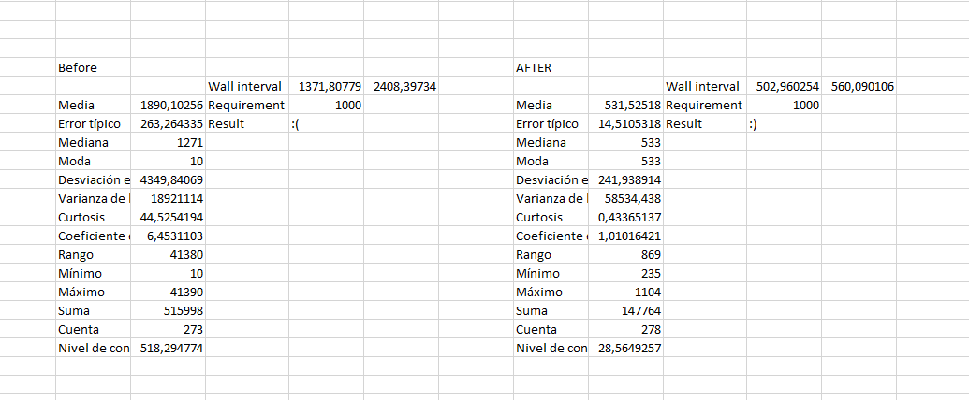

As we can see for the sample data it doesn’t satisfy the requirement time, as the wall time is above the required time. Our performance satisfies the requirement, as the time is less than the required time.

Now that we have the descriptive statistic, we are going to do the hypothesis contrast. There are several ways of doing it, we are going to choose the z test for two samples, as we have more than 50 samples for each test.

We use the calculated variance of each sample, and the hypothetic difference between them should be 0, but we will use an alpha threshold of 0.05. If the P(Z<=z) is less than 0.05 it means that the tests were run on different machines and cannot be compared.

